**Recipes for Shabbat-Mosaic – Lag-Ba’Omer**

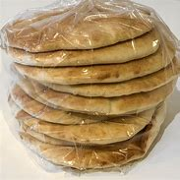

**Pita bread** – Buy from Giant/Shalom/Moti

**Tahini Paste** –

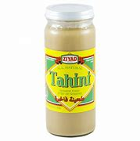 350 gr Tahini paste

Water

Lemon juice

salt

**Tabouli Salad**

1 cup bulgur

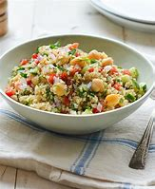1 Parsley

1 Cilantro

1 mint

2 green onion

¼ cup Lemon juice

2 tablespoon honey

Salt

Pepper

¼ cup olive oil

¼ cup dried cranberries

Chopp the Parsley, Cilantro, Mint, and Green onion

Mix all the ingredients and add the source

**Moses in a blanket**

Puffed Pastry

Hebrew National Sausage beef

Or buy it😊

**Shredded Beef**

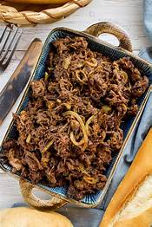2-pound roast beef

3 chopped onion

5 chopped garlic

¼ cup Silan (date paste) / Honey

¼ cup soy sauce

1/3 cup BBQ sauce

Salt

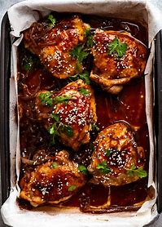**Chicken breast with a sweet marinade**

2 pound Chicken Breast

2 chopped garlic

Olive oil

Silan / Honey

Sweet & Sour Chili sauce

¼ cup chopped Cilantro

Salt

Pepper

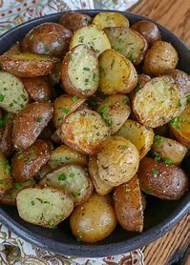**Potato with Rosemary**

1. Preheat the oven to 425°F. Chop the potatoes into bite-size pieces and place them in a large bowl. Drizzle with olive oil and toss with your hands to coat thoroughly.
2. Sprinkle generously with salt, pepper, and rosemary. Toss again to distribute the spices over all the pieces. Spread the potatoes across a well-oiled baking sheet.
3. Roast for 35-40 minutes, stirring the potatoes and turning them over with a large spatula at last once halfway through. Potatoes are done when they are fork-tender, golden brown, and slightly crisp on the edges

**Colorful Cabbage Salad**

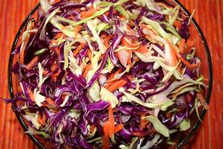½ chopped Green cabbage

½ chopped red cabbage

4-5 shredded red radish

2 shredded carrots

4 chopped green onion (Scallion)

1 cup chopped Parsley

Sauce: ¼ cup lemon juice, salt, pepper, 2 tablespoon mayo, ½ teaspoon sugar

.